**INTRODUCTION**

**INTRODUCTION**

The Objective of this app is to track society problems, solve it and easily manage society members. In this application User can get report of pending maintenance of society members, send notification, manage society events, competitions in society events, society events gallery, society members information management, send notifications, emergency contact details, society problems discussions and solutions, Global notice management, online payment of society fund etc. With this app there is no need to go door by door and inform about any new information related to society. Head of the society can send notification to the society members with his iOS(iPhone) Device.

**PROJECT PROFILE**

**PROJECT PROFILE**

|  |  |
| --- | --- |
| PROJECT TITLE | DIGITAL SOCIETY |
| PROJECT DURATION | 1 YEAR |
| TEAM STRENGTH | 3 MEMBERS |
| GROUP MEMBERS | DHRUV A. PATEL  JAINISH P. PATEL  PREYAS M. SAVANI |
| PROJECT GUIDE | Mrs. MAITRI N. JOSHI |

**TABLE 1 [PROJECT PROFILE]**

**SYSTEM ANALYSIS**

**SYSTEM ANALYSIS**

**Project Title:** Digital Society

**Project Definition:**

The Objective of this app is to track society problems, solve it and easily manage society members. In this application User can get report of pending maintenance of society members, send notification, manage society events, competitions in society events, society events gallery, society members information management, send notifications, emergency contact details, society problems discussions and solutions, Global notice management, online payment of society fund etc. With this app there is no need to go door by door and inform about any new information related to society. Head of the society can send notification to the society members with his iOS(iPhone) Device.

* **FUNCTIONAL REQUIREMENT**
* Access Multiple Application.
* **NON FUNCTIONAL REQUIREMENT**
* **Reliability:-** The system will consistently perform its intended function.

For e.g. the important information must be validated.

* **Efficiency:-** Unnecessary data will not be transmitted on the network and database server will be properly connected.
* **Reusability:-** The system can be reused in any organization or site of the same group, by defining the organization master definition under software license agreement.
* **Integrity:-** Only system administrator has rights to access the database, not every user can access all the information. Each user will be having rights to access the modules.

**TOOLS & TECHNOLOGIES**

* **Software Specification**
* **Front-end Tool:-** Xcode 10.0
* User friendly
* Low Cost Solution
* GUI feature
* Better designing aspects
* **Back-end Tool:-** PHP and MYSQL
* It’s easy to use.
* Secure: MYSQL includes solid data security layers
* It’s inexpensive.
* Fast
* Manage memory well.
* Works on multiple operating system.
* **PLATFORM:-**
* iOS PLATFORM: iOS(version 11.4) and above.
* **Hardware Specification**
* Processor 2.3 GHz Intel Core i5
* Processor speed – 2.1GHz
* Storage 256GB
* Ram 8GB

**DIAGRAMS**

**ENTITY RELATIONSHIP DIAGRAM**

An Entity Relationship Diagram (ERD) is a snapshot of data structure ERDs shows entities in a Database and relationship between tables within that database. It is essential to have one of these if you want to create a good database design. This help focus on how the database actually Works with all of interaction data flows.

Entity Relation Model is used to create data model which use top-down approach for database design. Diagrams emerge from this methodology is model generating process and end product of this process in E-R diagrams a type of Conceptual Data Model.

Entities, Relationships, and Attributes are building blocks of Entity-Relationship Model Entities are thought as nouns Examples: a computer, an employee, a song etc.

|  |  |  |
| --- | --- | --- |
| **Diamond** |  | **Relationship Identifying** |
| **Rectangle** |  | **Representing Entity** |
| **Oval** |  | **Representing attributes** |
| **Line** |  | **Link attributes and entity set** |

**TABLE 2 [E-R DIAGRAM SYMBOLS]**

**E-R DIAGRAM**

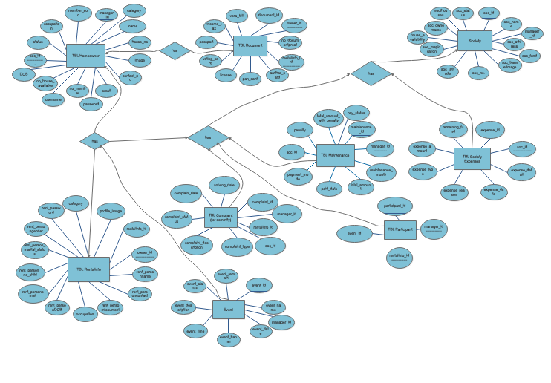

**FIGURE 1 [E-R DIAGRAM]**

**DATA FLOW DIAGRAM**

A graphical tool used to describe and analyze the moment of data through a system manual or automated including the process, stores of data, and delays in the system. Data Flow Diagrams are the central tool and the basis from which other components are developed. The transformation of data from input to output, through processes, may be described logically and independently of the physical components associated with the system.

A context-level DFD for the system the primary external entities round information for use by the system and consume information generated by the system. The labeled arrow represent data object or object hierarchy.

**Symbol:**

|  |  |  |
| --- | --- | --- |
| **Rectangle** |  | **Source or destination of data** |
| **Circle** |  | **Process that transforms data** |
| **Ray** |  | **Data flow** |
| **Database** |  | **Data store** |

**TABLE 3 [DATA FLOW DIAGRAM SYMBOLS]**

* **LEVEL 0 CONTEXT LEVEL DIAGRAM**

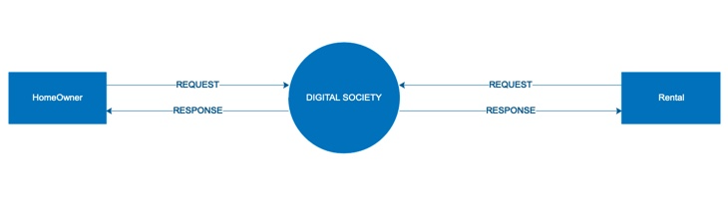

**FIGURE 2 [LEVEL 0 CONTEXT LEVEL DIAGRAM]**

* **LEVEL 1 DATAFLOW DIAGRAM FOR HOMEOWNER.**

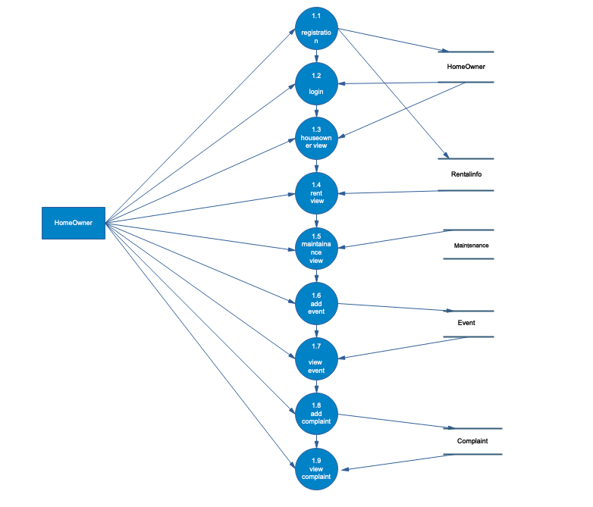

**FIGURE 3 [LEVEL 1 DIAGRAM FOR HOMEOWNER]**

* + **LEVEL 1 DATAFLOW DIAGRAM FOR RENTAL.**

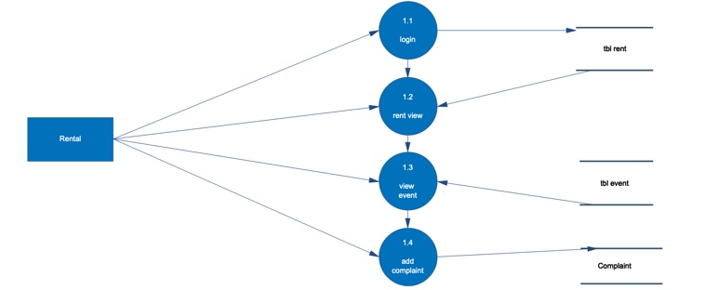

**FIGURE 4 [LEVEL 1 DIAGRAM FOR RENTAL]**

**TABLE SPECIFICATION**

**TABLE SPECIFICATION**

**Table Name:- Homeowner**

|  |  |  |
| --- | --- | --- |
| **FIELD** | **DATA-TYPE** | **SIZE** |
| Category | Varchar | 20 |
| Manager_id | Integer | 10 |
| Name | Varchar | 30 |
| House_no | Varchar | 20 |
| Image | Varchar | 500 |
| Contact_no | Varchar | 10 |
| Email | Varchar | 25 |
| No_member | Varchar | 30 |
| No_house_available | Varchar | 20 |
| Soc_id | Varchar | 10 |
| Status | Varchar | 20 |
| Occupation | Varchar | 20 |
| Member_soc | Varchar | 50 |
| DOB | Date | - |
| Password | Varchar | 16 |

**Table Name:- Society**

|  |  |  |
| --- | --- | --- |
| **FIELD** | **DATA-TYPE** | **SIZE** |
| Soc_id | Integer | 11 |
| Soc_name | Varchar | 30 |
| Soc_address | Varchar | 50 |
| Soc_BannerImage | Varchar | 500 |
| Soc_no. | Integer | 10 |
| Soc_latitude | Integer | 30 |
| Soc_maplocation | Varchar | 30 |
| Soc_ownername | Varchar | 20 |
| Soc_status | Varchar | 20 |
| Manager_id | Integer | 11 |
| Noofhouses | Varchar | 20 |
| House_availability | Varchar | 20 |
| Soc_fund | Integer | 20 |

**Table Name:- RentalInfo**

|  |  |  |
| --- | --- | --- |
| **FIELD** | **DATA-TYPE** | **SIZE** |
| Rentalinfo_id | Integer | 20 |
| Owner_id | Integer | 10 |
| Rent_personname | Varchar | 20 |
| Rent_personcontact | Varchar | 10 |
| Rent_persondocument | Varchar | 500 |
| Occupation | Varchar | 20 |
| Rent_personDOB | Varchar | 20 |
| Rent_personemail | Varchar | 30 |
| Rent_person_no_child | Integer | 10 |
| Rent_person_marital_status | Varchar | 10 |
| Rent_persongender | Varchar | 10 |
| Rent_password | Varchar | 20 |
| Category | Varchar | 20 |
| Profile_image | Varchar | 500 |

**Table Name:- Document**

|  |  |  |
| --- | --- | --- |
| **FIELD** | **DATA-TYPE** | **SIZE** |
| Document_id | Integer | 11 |
| Owner_id | Integer | 10 |
| No_documentproof | Integer | 10 |
| Rentalinfo_id | Integer | 10 |
| Aadhar_card | Varchar | 1000 |
| Pan_card | Varchar | 1000 |
| License | Varchar | 1000 |
| Voting_card | Varchar | 1000 |
| Passport | Varchar | 1000 |
| Income_tax | Varchar | 1000 |
| Vera_bill | Varchar | 1000 |

**Table Name:- Event**

|  |  |  |
| --- | --- | --- |
| **FIELD** | **DATA-TYPE** | **SIZE** |
| Event_id | Integer | 11 |
| Event_name | Varchar | 30 |
| Event_date | Date | - |
| Event_banner | Varchar | 1000 |
| Event_time | Time | - |
| Event_description | Varchar | 1000 |
| Event_status | Varchar | 30 |
| Event_remark | Varchar | 100 |
| Manager_id | Varchar | 20 |

**Table Name:- Participant**

|  |  |  |
| --- | --- | --- |
| **FIELD** | **DATA-TYPE** | **SIZE** |
| Participant_id | Integer | 10 |
| Manager_id | Integer | 10 |
| Rentalinfo_id | Varchar | 20 |
| Event_id | Integer | 11 |

**Table Name:- Maintenance**

|  |  |  |
| --- | --- | --- |
| **FIELD** | **DATA-TYPE** | **SIZE** |
| Maintenance_id | Integer | 20 |
| Manager_id | Integer | 10 |
| Maintenance_month | Varchar | 20 |
| Total_amount | Integer | 20 |
| Paid_date | Date | - |
| Payment_mode | Varchar | 20 |
| Penalty | Integer | 20 |
| Total_amount_with_penalty | Integer | 20 |
| Soc_id | Integer | 20 |
| Pay_status | Varchar | 20 |

**Table Name:- Complaint**

|  |  |  |
| --- | --- | --- |
| **FIELD** | **DATA-TYPE** | **SIZE** |
| Complaint_id | Integer | 20 |
| Manager_id | Varchar | 20 |
| Rentalinfo_id | Varchar | 20 |
| Complaint_type | Varchar | 200 |
| Complaint_description | Varchar | 1000 |
| Complaint_status | Varchar | 20 |
| Complaint_date | Date | - |
| Solving_date | Date | - |
| Soc_id | Integer | 20 |

**Table Name:- SocietyExpenses**

|  |  |  |
| --- | --- | --- |
| **FIELD** | **DATA-TYPE** | **SIZE** |
| Expense_id | Integer | 20 |
| Soc_id | Varchar | 20 |
| Expense_detail | Varchar | 500 |
| Expense_date | Date | - |
| Expense_reason | Varchar | 200 |
| Expense_type | Varchar | 20 |
| Expense_amount | Integer | 20 |
| Remaining_fund | Integer | 20 |

**SNAPSHOTS**

* **SPLASH SCREEN**

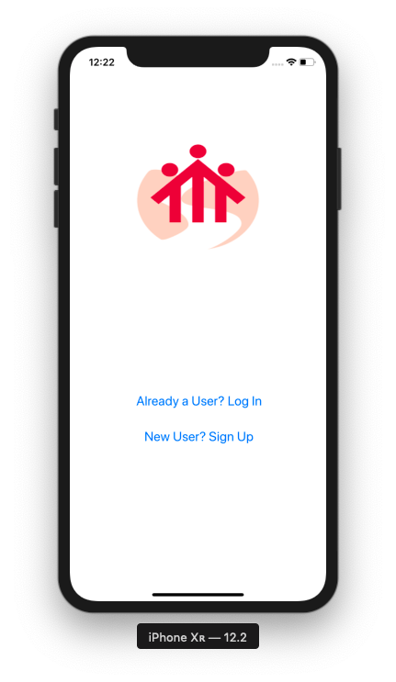

* This Is The First Page If The Application Doesn’t Have Any User Data And Using Application For The First Time. Here A User Can Choose Two Options (Log In / Sign Up), If A User Have Already An Account Then A User Can Log In Directly Otherwise Sign Up For A New Account.
* **HOME OWNER REGISTRATION**

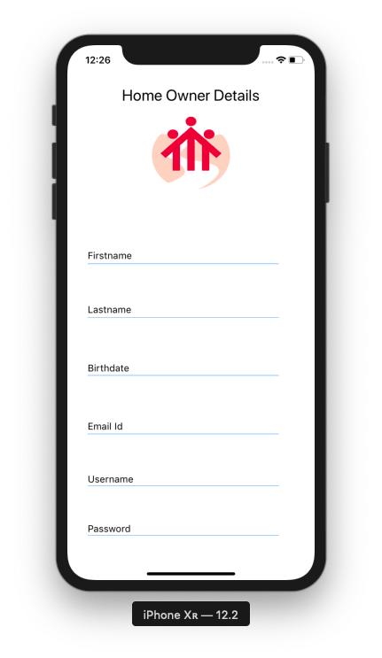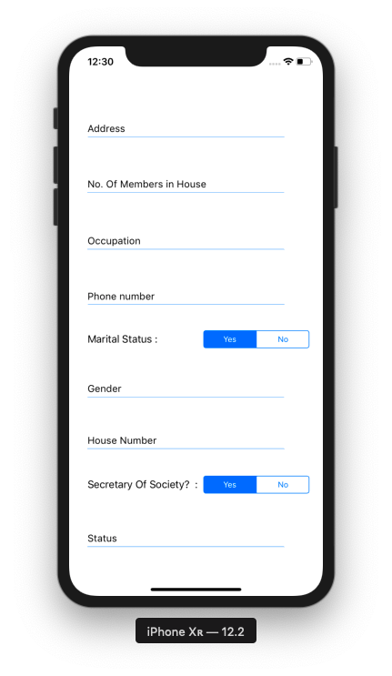

* This Is The Registration Page Of The Home Owner (Secretary / Member) Where A User Can Register Itself But It Can Only Be Validated If The Admin Of The App Registers A Secretary With A Society Name. A Secretary Has To Request An Email Or Contact Developer To Get Access To The Secretary Account.
* **HOME OWNER LOGIN**

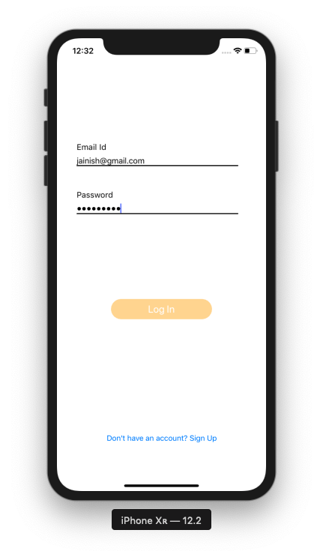

* This Is The Login Page For A Secretary, As All Users Have A Same Page For Login It Only Validates From The Provided Email And Password From The Database.
* **HOME PAGE**

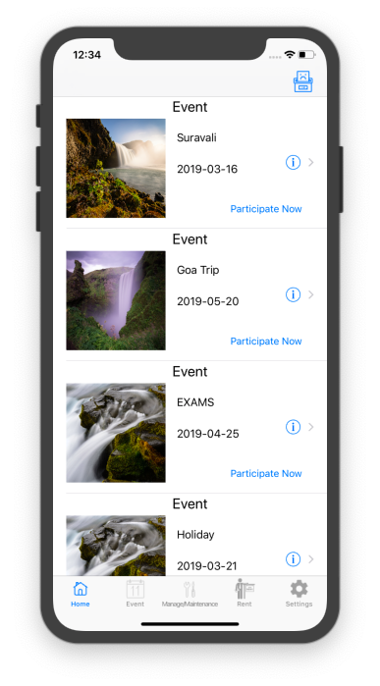

* This Is The Home Page Of The Secretary, Where A Secretary Can Add Complaint, View Event Details, And Participate In An Event.
* **EVENT DETAILS**

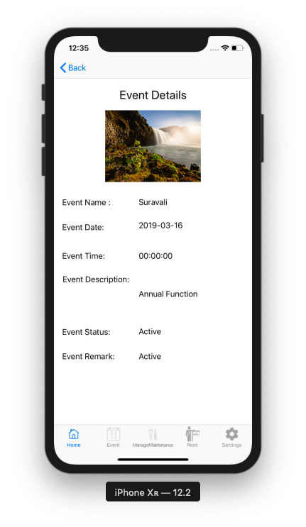

* This Page Is Used To Get The Details For An Event, A User Can View The Information Of The Event, Which Is Clicked.
* **PARTICIPATE ACTION**

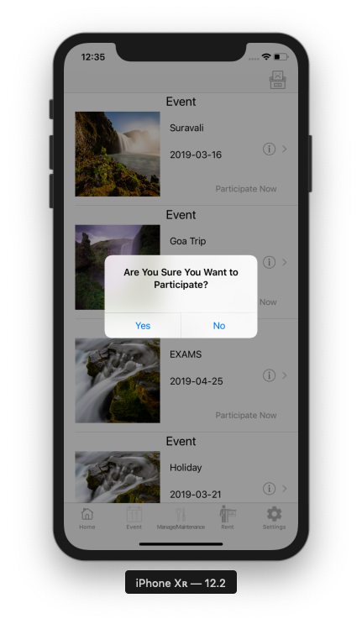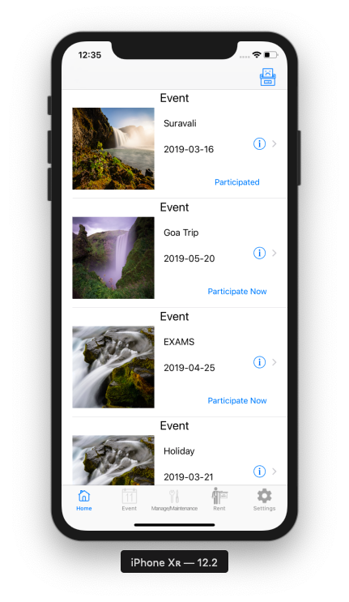

* This Is The Participate Action Of The Event On The Home Page, If Clicked On “Participate Now” It Displays A Popup For Asking To Participate In An Event, If User Clicks “Yes” Then It Automatically Fetches Data From The User’s Data Provided In The Database.
* **REGISTER AN EVENT**

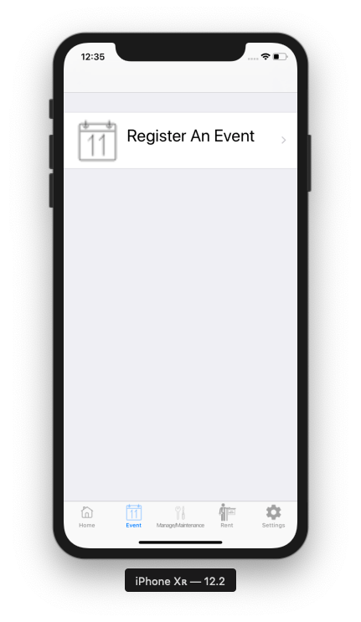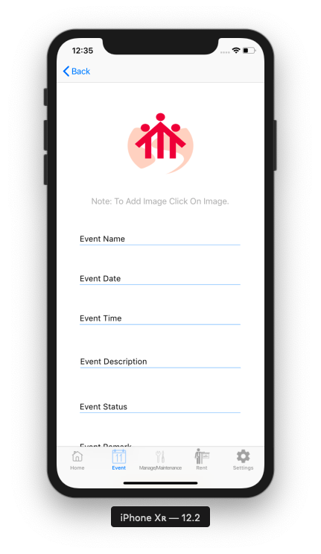

* This Is A Event Tab Of The Secretary, Where A Secretary Can Register An Event By Giving Specific Details To The TextFields.
* **MANAGE/MAINTENANCE TAB**

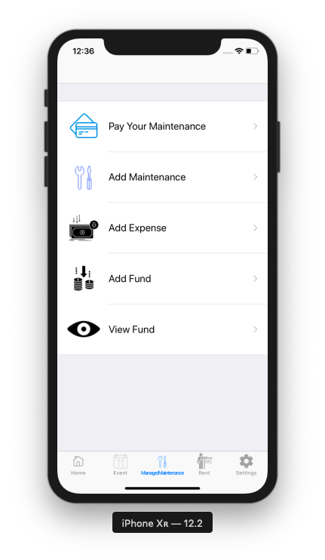

* This Is The Manage / Maintenance Tab Of Secretary, Where A Secretary Can Perform Various Actions Such As Pay Maintenance, Add Maintenance, Add Expense, Add Fund And View Fund.
* **ADD MAINTENANCE**

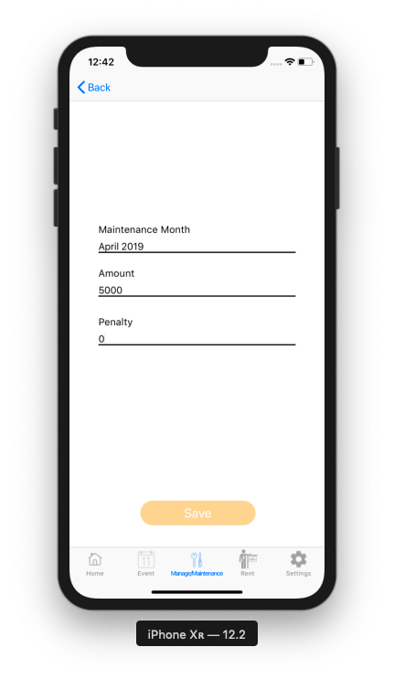

* This Is Add Maintenance Action, Where A Secretary Can Add The Maintenance For Each And Every Month With Applied Penalty (If Required).
* **PAY MAINTENANCE**

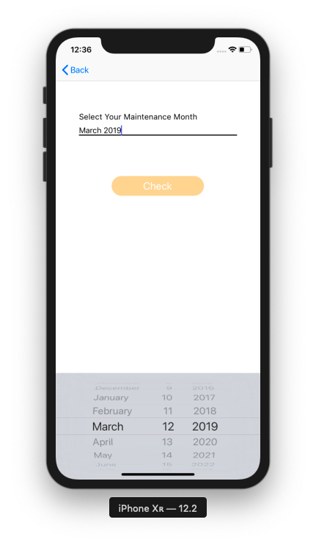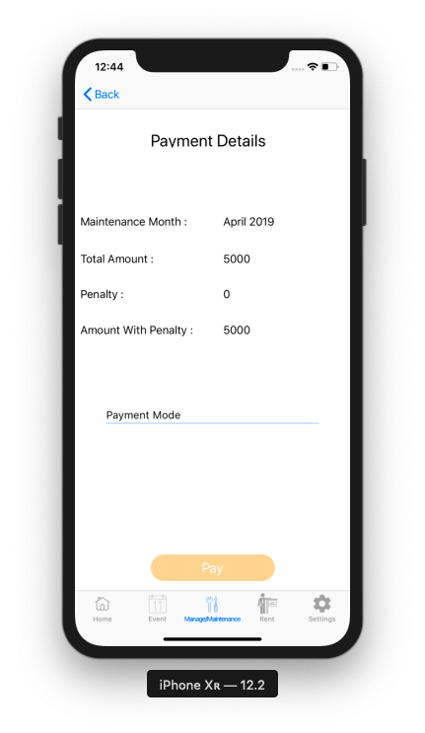

* This Is The Pay Maintenance Action For The Secretary, Where A Secretary Can Pay The Maintenance By Various Payment Modes.
* **ADD EXPENSE**

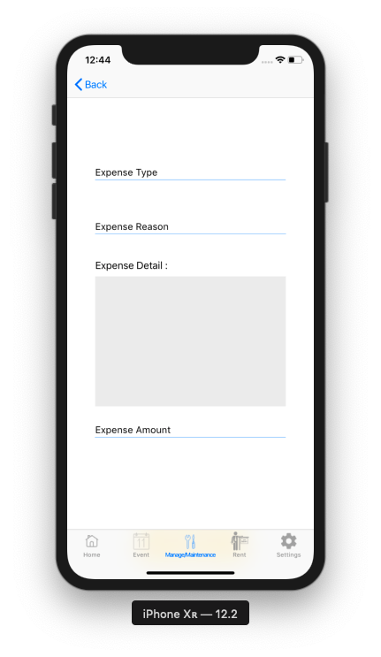

* This Is Add Expense Of The Society, Where A Secretary Can Add Expense For The Society.
* **ADD FUND**

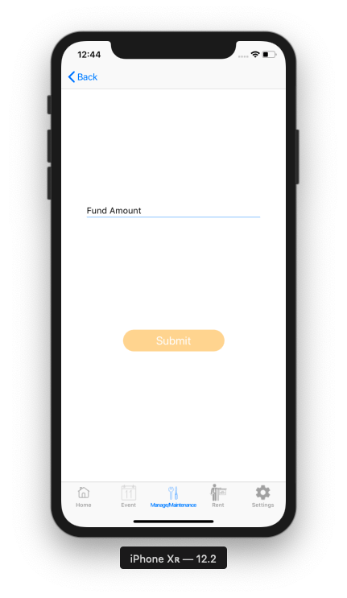

* This Is Add Fund Action, Where A Secretary Can Add External Fund To The Society.
* **TOTAL FUND**

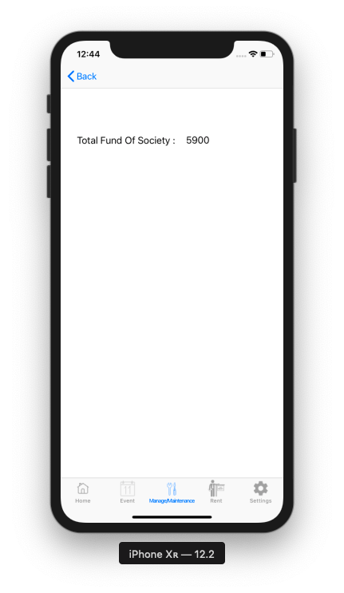

* This Is A The Total Fund Of The Society, Where User Can View Total Fund Of The Society.
* **RENT MANAGEMENT TAB**

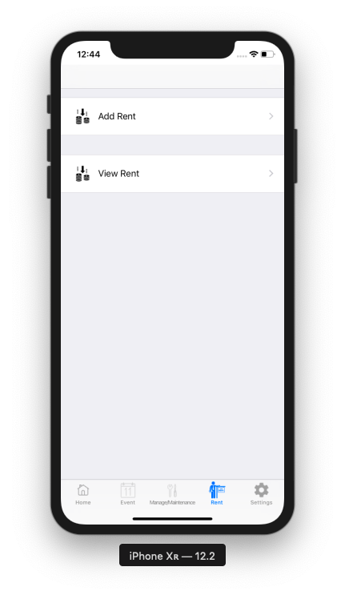

* This is the Rent Tab Of Secretary Where A Secretary Can Add Rental User and View Rental User’s Details.
* **ADD RENT / VIEW RENT**

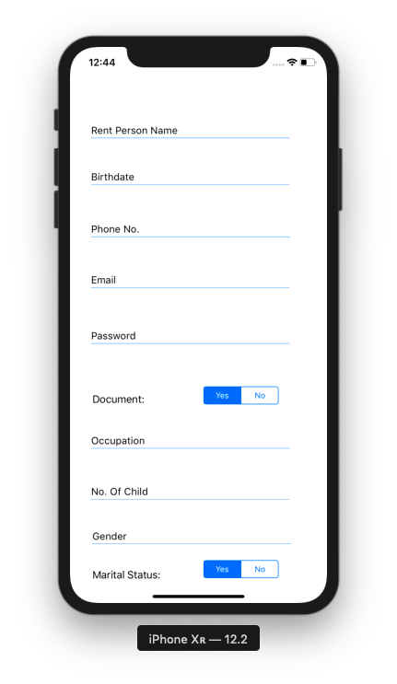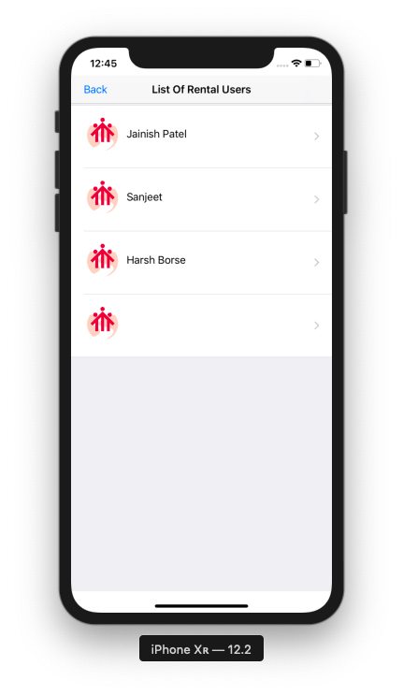

* This Is Add Rent And View Rent Demo, In Add Rent A Secretary Can Add Rental User’s Details And Register With A Provided Email And Password And In View Rental User A Secretary Can View His / Her Basic Details.
* **SETTINGS TAB**

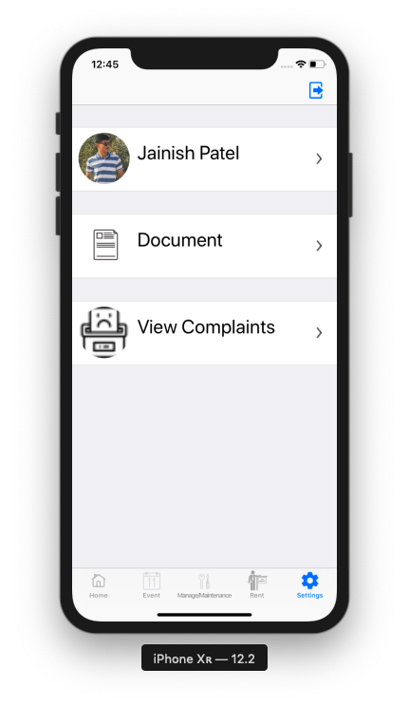

* This Is The Settings Tab For Secretary Where A Secretary Can Update Profile, Upload Document And View Complaints.
* **PROFILE UPDATE**

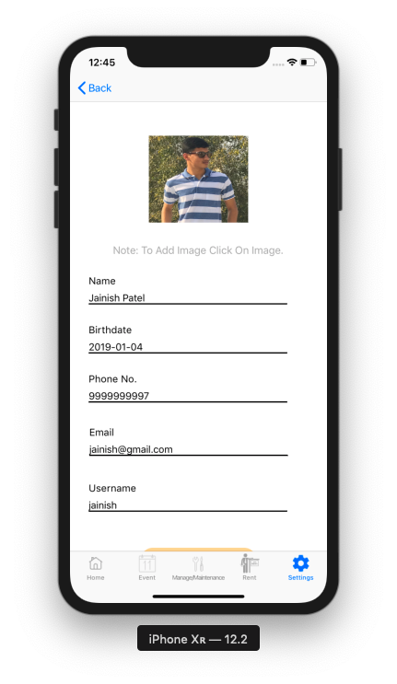

* This Is Profile Update Section For The Secretary Tab, Where User Can Update Their Basic Settings.
* **DOCUMENT UPLOAD**

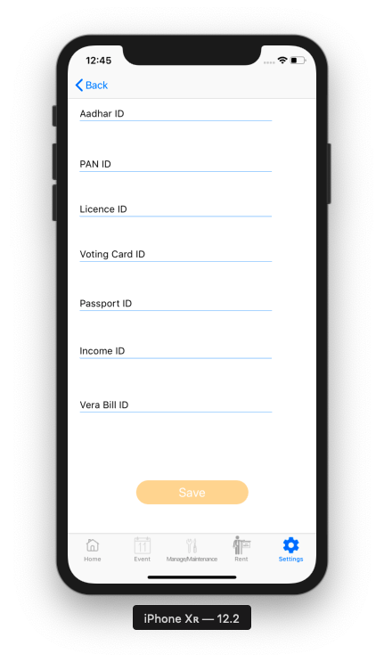

* This Is The Document Action For Secretary, In Which Secretary Can Upload Their Documents.
* **VIEW COMPLAINTS**

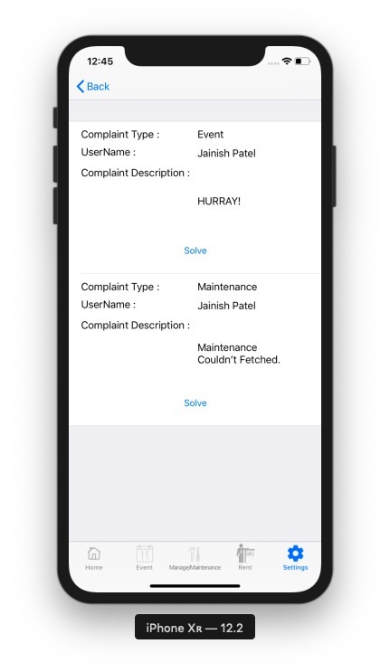

* This Is View Complaint Action For Secretary, It Shows All The Complaint Related To Society And Secretary Can View And Solve It.
* **LOGOUT USER**

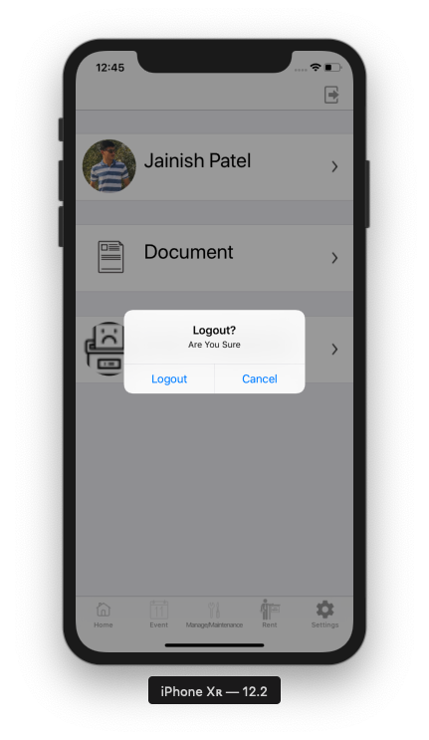

* This Is The Logout Popup For Secretary To Logout User From The Application.
* **MEMBER LOGIN**

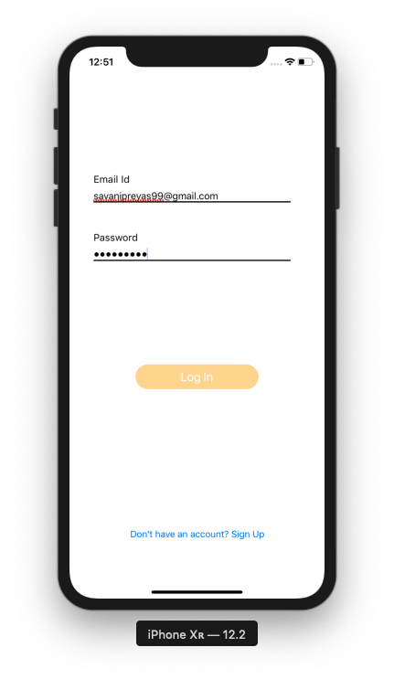

* This is Login Page for Member, It is As Same As For Rental User and Secretary, Because it verifies a user from the database server.
* **MEMBER HOME TAB**

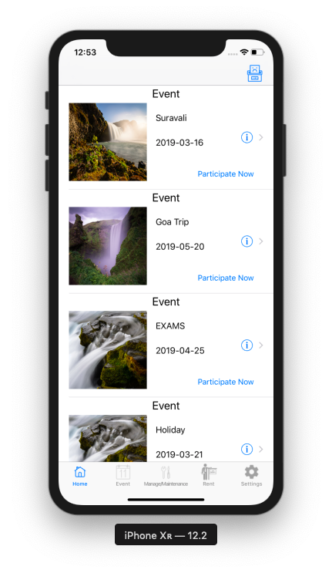

* This Is The Homepage Of The Member User Of The Society, Where A User An Add Complaint, Participate In Any Event Or Get The Details About An Event.
* **EVENT TAB**

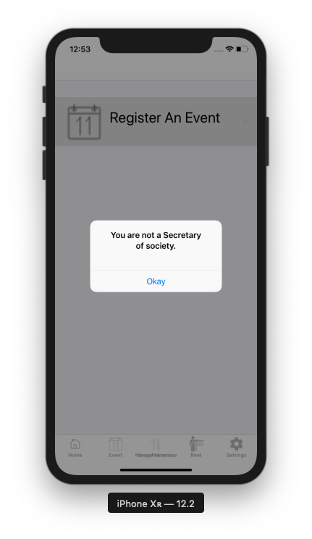

* This Is Event Tab Of The Member But, It Can’t Be Accessed By The Member Because An Event Can Only Be Registered By Secretary.
* **MANAGE / MAINTENANCE TAB**

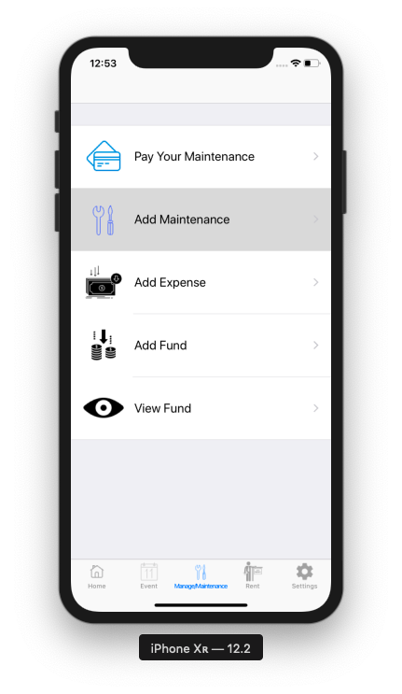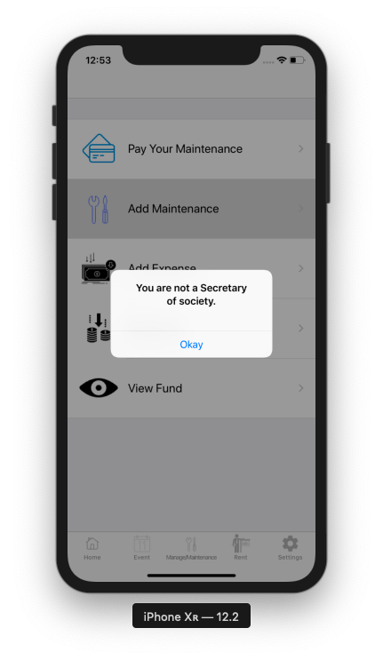

* This Is The Manage/Maintenance Tab Of Member, Where A Member Of The Society Can Pay Maintenance Of Each And Every Month And View Fund Of The Society. Member Of The Society Cannot Access Other Information Such As Add Maintenance, Add Expense And Add Fund Because, It Can Only Be Handled By Secretary Of The Society.
* **RENT TAB**

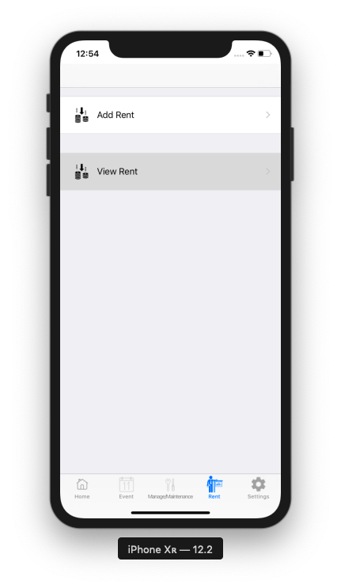

* This is the Rent Tab For Member, Where A Member of society can add rental user and view rental users.
* **SETTINGS TAB**

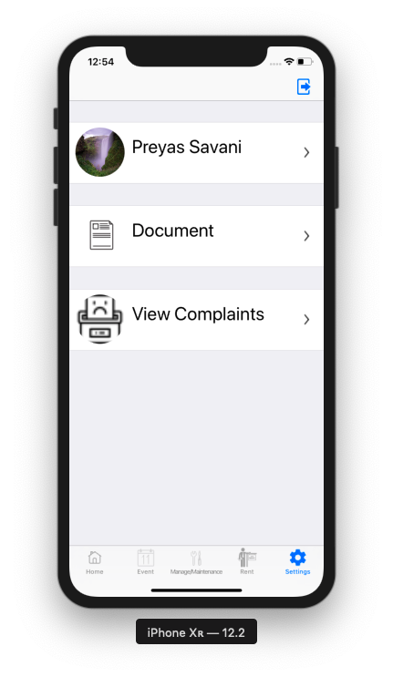

* This Is The Settings Tab For Member, Where Member Can Update Basic Profile Settings And Document.
* **PROFILE UPDATE**

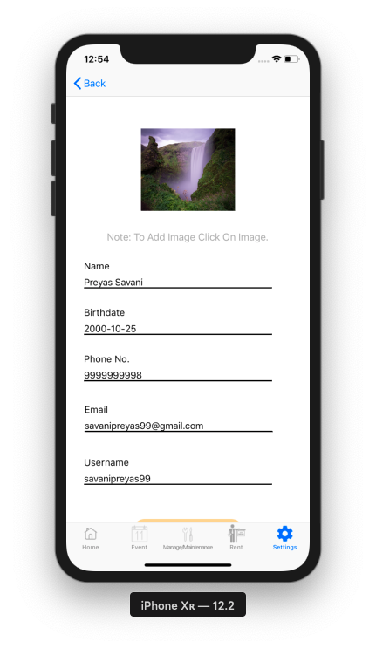

* This Is Profile Update For Member, Where User Can Update Basic Profile Settings For User.
* **COMPLAINT ACTION**

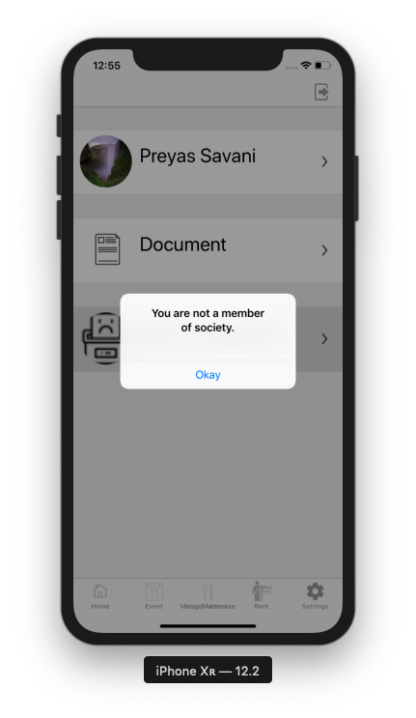

* This Is View Complaint Action, Which Can Only Be Accessed By Secretary Of A Society.
* **RENTAL USER LOGIN**

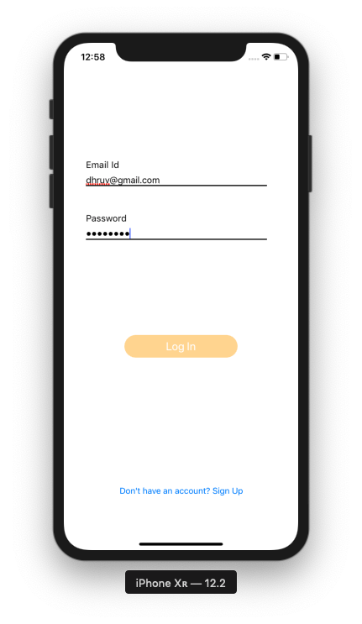

* This Is A Login For Rental User Same As For Secretary And Member But It Validates User From The Database Server.
* **RENTAL USER HOME TAB**

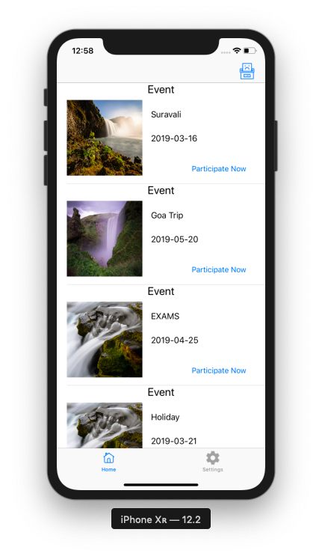

* This Is A Home Page For Rental User, Which Can Add Complaint And Manage Events.
* **SETTINGS TAB FOR RENTAL USER**

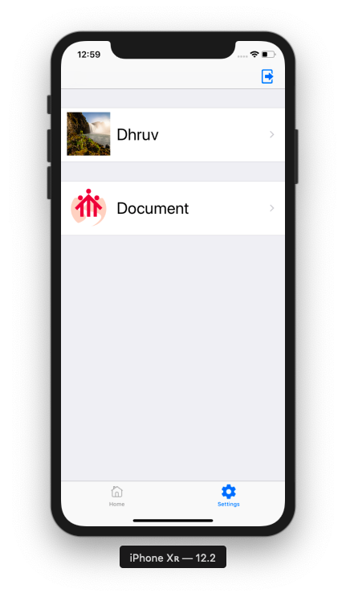

* This Is Settings Tab For Rental User, Which Manages User Profile And Document Management.
* **PROFILE UPDATE FOR RENTAL USER**

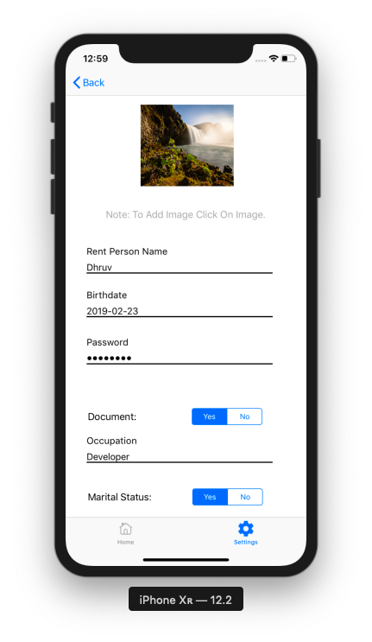

* This Is The Basic Need For Every Rental To Update Their Own Profile.
* **DOCUMENT UPDATE FOR RENTAL USER**

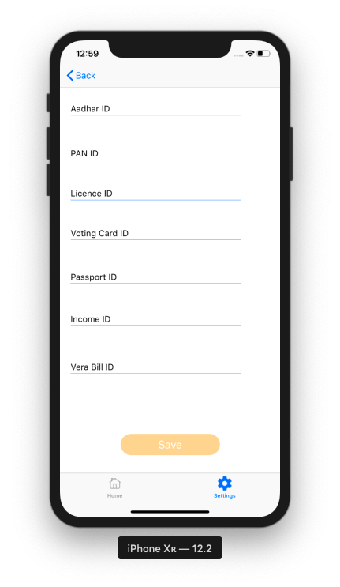

* This Is Used To Add Document For Verifying User.

**ADVANTAGES**

**ADVANTAGES**

* It is easy for society members and secretary.
* It is secure and sustainable digital society which benefits from the internet and digital.
* The impact of leaving within this digital society can have extremely valuable results.
* It is more valuable for our future generation.
* The project Digital Society is very Flexible for secretary and members.

**DISADVANTAGES**

**DISADVANTAGES**

* iOS device is required.
* Requires reliable internet connection.

**FUTURE SCOPE**

**FUTURE SCOPE**

* This Project Can Be Further Enhanced And Several Other Functionalities Can Be Added.
* Later, Database Server Can Be Purchased For Security Purpose.
* Payment Gateway Will Be Added In Future.
* Notification Alert For Maintenance To Be Paid Will Be Added In Future.
* SMS And Email Server Will Be Added To Notify User About Various Events And Payment of Maintenance.
* A Gallery For Society Where Previous Images Of An Event Can Be Viewed.

**CONCLUSION**

**CONCLUSION**

The Objective Of This App Is To Track Society Problems, Solve It And Easily Manage Society Members. In This Application User Can Get Report Of Pending Maintenance Of Society Members, Send Notification, Manage Society Events, Competitions In Society Events, Society Events Gallery, Society Members Information Management, Send Notifications, Emergency Contact Details, Society Problems Discussions And Solutions, Global Notice Management, Online Payment Of Society Fund Etc.

**BIBLIOGRAPHY**

**BIBLIOGRAPHY**

* **WEBSITE**
* www.github.com
* www.iosawesome.com

**STUDENT’S SELF APPRAISAL**

N.G.PATEL POLYTECHNIC

COMPUTER ENGINEERING DEPARTMENT

DHRUV A. PATEL 166370307033

|  |  |  |  |  |  |
| --- | --- | --- | --- | --- | --- |
| **STUDENT'S SELF APPRAISAL FORM FOR UDP PART-I** | | | | | |
|  | **As a UDP Group** | A | B | C | D |
| 1 | All Students of group understood and agreed on how the whole project was broken down into sub-tasks. |  |  |  |  |
| 2 | Work was distributed according to the skills and knowledge and capacity of each student. |  |  |  |  |
| 3 | All Students were clear about the time frame and their own responsibilities. |  |  |  |  |
| 4 | All students involved understood that their work would contribute to the group's success. |  |  |  |  |
| 5 | Individual difficulties experienced by individuals were discussed in the group and other students helped to resolve the difficulties. |  |  |  |  |
|  | **The Task Execution** | A | B | C | D |
| 6 | The work was perfectly & clearly distributed among all students. |  |  |  |  |
| 7 | The timing and sequencing of sub-tasks done to progress stage by stage. |  |  |  |  |
| 8 | Survey and Data collected were organized systematically for later use. |  |  |  |  |
| 9 | On-going checking throughout the process was made to ensure that everything was on the right track. |  |  |  |  |
| 10 | Appropriate corrective measures were taken to handle unexpected problems. |  |  |  |  |
| 11 | The quality of work produced was assessed regularly during the process and also at the end. |  |  |  |  |
| 12 | Systematic Survey and Literature study done. |  |  |  |  |
|  | **My Roll in the UDP Group** | A | B | C | D |
| 13 | I tried my level best to accomplish the part I taken and in time. |  |  |  |  |
| 14 | I tried my level best to complete UDP and produce good quality Solution. |  |  |  |  |
| 15 | I feel strongly that the group success is my own success. |  |  |  |  |
| 16 | I feel that this UDP is a Real life Problem. |  |  |  |  |
| 17 | I learned from other students of the Group. |  |  |  |  |
| **Marking: A= Strongly in favour, B = Moderately in favour, C = Not Much, D = Not at all** | | | | | |

N.G.PATEL POLYTECHNIC

COMPUTER ENGINEERING DEPARTMENT

JAINISH P. PATEL 166370307039

|  |  |  |  |  |  |
| --- | --- | --- | --- | --- | --- |
| **STUDENT'S SELF APPRAISAL FORM FOR UDP PART-I** | | | | | |
|  | **As a UDP Group** | A | B | C | D |
| 1 | All Students of group understood and agreed on how the whole project was broken down into sub-tasks. |  |  |  |  |
| 2 | Work was distributed according to the skills and knowledge and capacity of each student. |  |  |  |  |
| 3 | All Students were clear about the time frame and their own responsibilities. |  |  |  |  |
| 4 | All students involved understood that their work would contribute to the group's success. |  |  |  |  |
| 5 | Individual difficulties experienced by individuals were discussed in the group and other students helped to resolve the difficulties. |  |  |  |  |
|  | **The Task Execution** | A | B | C | D |
| 6 | The work was perfectly & clearly distributed among all students. |  |  |  |  |
| 7 | The timing and sequencing of sub-tasks done to progress stage by stage. |  |  |  |  |
| 8 | Survey and Data collected were organized systematically for later use. |  |  |  |  |
| 9 | On-going checking throughout the process was made to ensure that everything was on the right track. |  |  |  |  |
| 10 | Appropriate corrective measures were taken to handle unexpected problems. |  |  |  |  |
| 11 | The quality of work produced was assessed regularly during the process and also at the end. |  |  |  |  |
| 12 | Systematic Survey and Literature study done. |  |  |  |  |
|  | **My Roll in the UDP Group** | A | B | C | D |
| 13 | I tried my level best to accomplish the part I taken and in time. |  |  |  |  |
| 14 | I tried my level best to complete UDP and produce good quality Solution. |  |  |  |  |
| 15 | I feel strongly that the group success is my own success. |  |  |  |  |
| 16 | I feel that this UDP is a Real life Problem. |  |  |  |  |
| 17 | I learned from other students of the Group. |  |  |  |  |
| **Marking: A= Strongly in favour, B = Moderately in favour, C = Not Much, D = Not at all** | | | | | |

N.G.PATEL POLYTECHNIC

COMPUTER ENGINEERING DEPARTMENT

PREYAS M. SAVANI 166370307051

|  |  |  |  |  |  |
| --- | --- | --- | --- | --- | --- |
| **STUDENT'S SELF APPRAISAL FORM FOR UDP PART-I** | | | | | |
|  | **As a UDP Group** | A | B | C | D |
| 1 | All Students of group understood and agreed on how the whole project was broken down into sub-tasks. |  |  |  |  |
| 2 | Work was distributed according to the skills and knowledge and capacity of each student. |  |  |  |  |
| 3 | All Students were clear about the time frame and their own responsibilities. |  |  |  |  |
| 4 | All students involved understood that their work would contribute to the group's success. |  |  |  |  |
| 5 | Individual difficulties experienced by individuals were discussed in the group and other students helped to resolve the difficulties. |  |  |  |  |
|  | **The Task Execution** | A | B | C | D |
| 6 | The work was perfectly & clearly distributed among all students. |  |  |  |  |
| 7 | The timing and sequencing of sub-tasks done to progress stage by stage. |  |  |  |  |
| 8 | Survey and Data collected were organized systematically for later use. |  |  |  |  |
| 9 | On-going checking throughout the process was made to ensure that everything was on the right track. |  |  |  |  |
| 10 | Appropriate corrective measures were taken to handle unexpected problems. |  |  |  |  |
| 11 | The quality of work produced was assessed regularly during the process and also at the end. |  |  |  |  |
| 12 | Systematic Survey and Literature study done. |  |  |  |  |
|  | **My Roll in the UDP Group** | A | B | C | D |
| 13 | I tried my level best to accomplish the part I taken and in time. |  |  |  |  |
| 14 | I tried my level best to complete UDP and produce good quality Solution. |  |  |  |  |
| 15 | I feel strongly that the group success is my own success. |  |  |  |  |
| 16 | I feel that this UDP is a Real life Problem. |  |  |  |  |
| 17 | I learned from other students of the Group. |  |  |  |  |
| **Marking: A= Strongly in favour, B = Moderately in favour, C = Not Much, D = Not at all** | | | | | |